Unit 01 Problem Set Submission Form

# Overview

|  |  |
| --- | --- |
| Your Name | Hrishikesh Telang |
| Your SU Email | hmtelang@syr.edu |

# Instructions

Put your name and SU email at the top. Answer these questions all from the lab. When asked to include screenshots, please follow the screen shot guidelines from the first lab.

Remember as you complete the problem sets it is not only about getting it right / correct. We will discuss the answers in class so it’s important to articulate anything you would like to contribute to the discussion in your answer:

* If you feel the question is vague, include any assumptions you've made.
* If you feel the answer requires interpretation or justification provide it.
* If you do not know the answer to the question, articulate what you tried and how you are stuck.

This how you receive credit for answering questions which might not be correct.

# Questions

1. Use docker-compose to start the containers. What is the command you typed to do this?  
   **docker-compose up -d**
2. What is the command to show the running docker containers?   
   **docker-compose ps**
3. Provide a screenshot displaying evidence your containers are running (the output of the previous question should suffice).  
   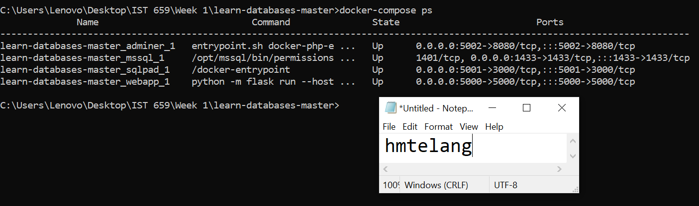
4. Provision all the databases included in the Database provisioner application. Provide a screenshot as evidence they have been provisioned. Note: This might take some time so be patient!  
   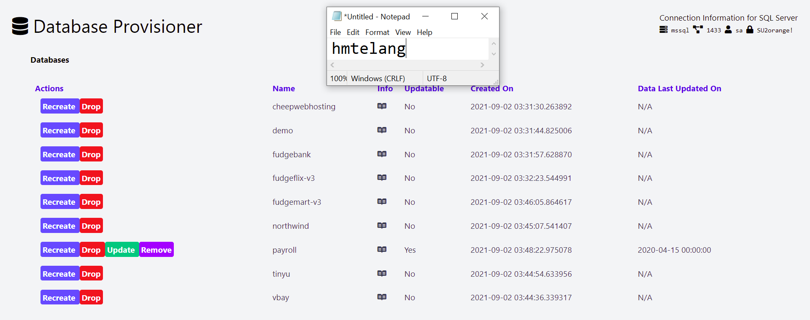
5. Connect to MS SQL Server using azure data studio and provide a screenshot of the databases under the connection. This will provide evidence your connection works and your databases were provisioned.  
   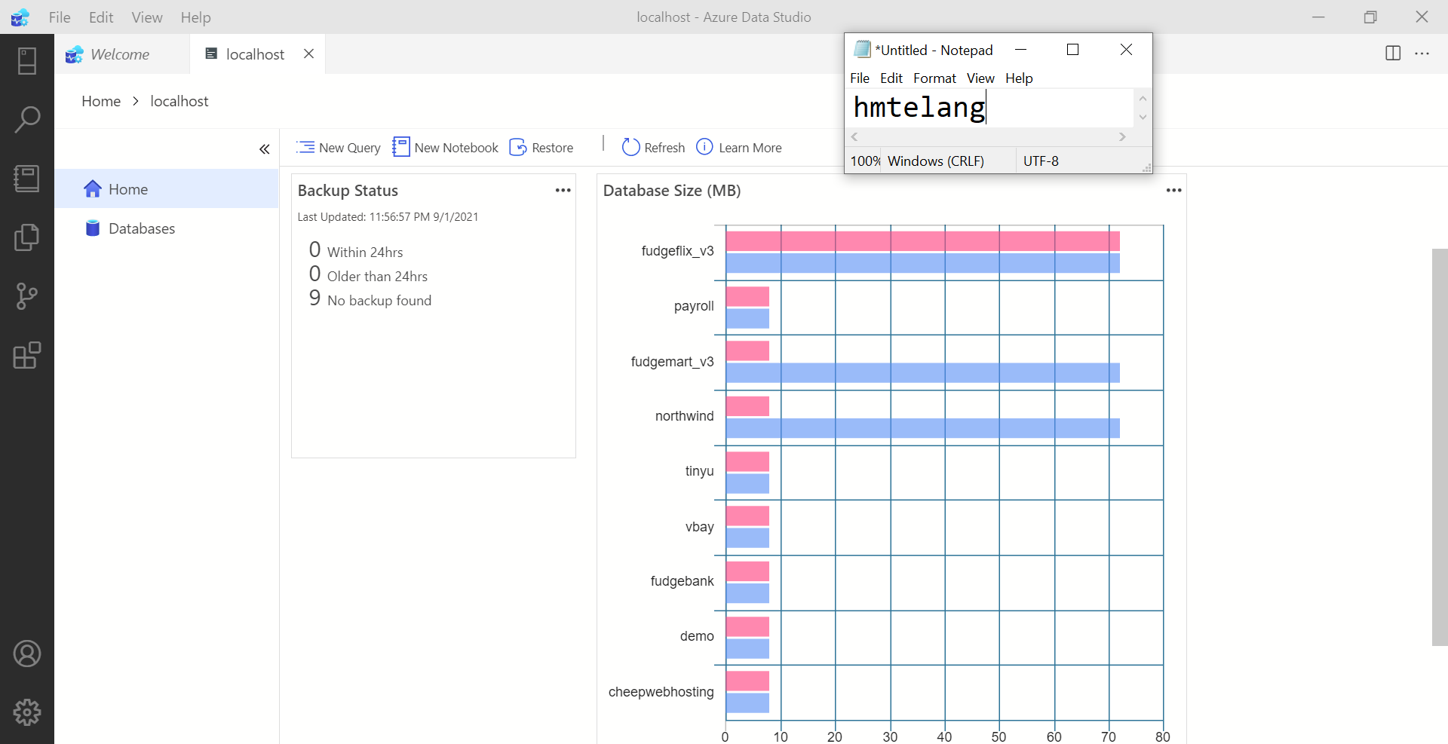

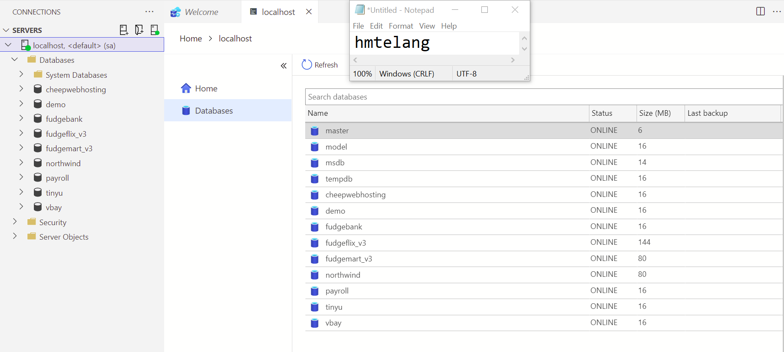

1. Connect to MS SQL server using SQL Pad. Specifically connect to the **payroll** database and then run this query: select * from department_lookup  
   Include a screenshot of the query and output.   
   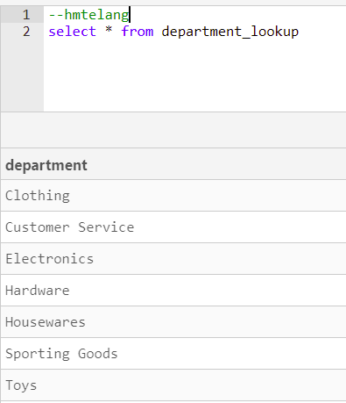
2. Connect to MS SQL server using Adminer, again connect to the **payroll** database. Include a screenshot of the structure of the **employees** table.  
   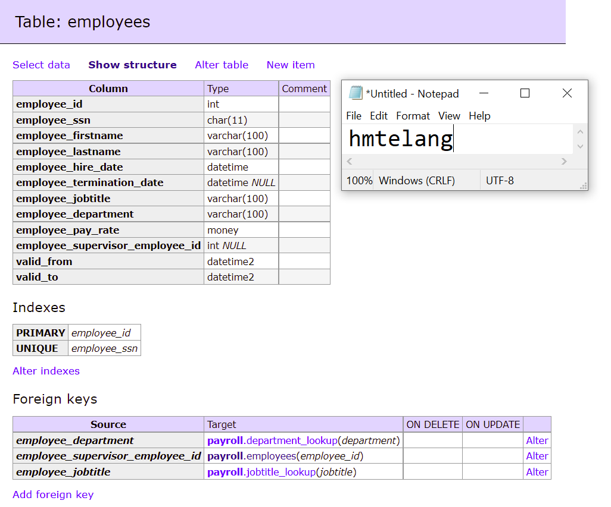
3. What is the command to shut down the running docker containers?  
   **docker-compose down**
4. Provide a screenshot displaying evidence your containers are no longer running (the output of the previous question should suffice).  
   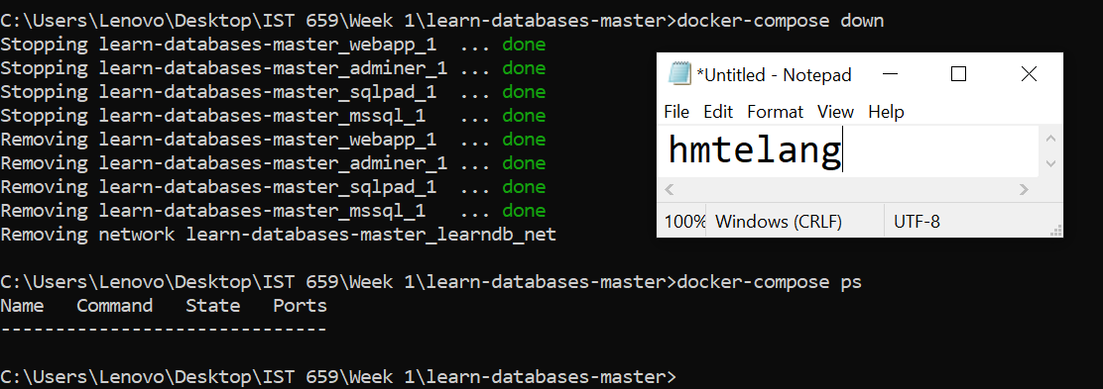

# Reflection

Use this section to reflect on your learning. To achieve the highest grade on the assignment you must be as descriptive and personal as possible with your reflection.

1. What are the key things you learned through the process of completing this assignment?  
   **I learnt about how Docker generally works, I also learnt that there are four database tools in the form of Docker Containers such as adminer, mssql, sqlpad, and Database Provisioner which are .yaml files already set up by Professor Fudge: all we had to do was get into the right directory through the Terminal and enter the docker-compose commands to install the environments. I learnt how Adminer is efficient at helping us visualize the entire schema of the tables and its relationship with the other tables in the database. And just like that, we have two databases such as SQLPad and Azure Data Studio over which we program in MS SQL. We also have a Database Provisioner that can help us access all of our databases across any of the container platforms.**
2. What were the challenges or roadblocks (if any) you encountered on the way to completing it?  
   **I was unable to start Docker because of virtualization issues, was also losing my hopes and wanted to seek help from Michael Fudge, until it started working well. I used StackOverflow and Docker Troubleshoot to solve my troubleshoots and roadblocks.**
3. Were you prepared for this assignment? What can you do to be better prepared?  
   **At first I was not prepared for this assignment. I did not know anything about Docker. After watching the lab video of Professor Fudge, I only have a rudimentary knowledge pertaining to this environment. I personally believe I can further fortify my knowledge by practicing this process over and over again to get the feel of the platform.**
4. Now that you have completed the assignment rate your comfort level with this week’s material. This should be an honest assessment: (choose one)  
     
   4 ==> I understand this material and can explain it to others.  
   **3 ==> I understand this material.**2 ==> I somewhat understand the material but sometimes need guidance from others.  
   1 ==> I understand very little of this material and need extra help.